# INTERNATIONAL CONFERENCE TO HIGHLIGHT BRISBANE’S WORLD LEADING STREPTOCOCCAL RESEARCH

The Lancefield International Symposium on Streptococci and Streptococcal Diseases (LISSSD), will provide a global forum for Queensland’s ground-breaking research, leading to human vaccine trials for Strep A, responsible for more than 500,000 deaths globally each year.

The Symposium will take place at the ASM Global managed [Brisbane Convention & Exhibition Centre](https://www.bcec.com.au) (BCEC) in June 2025, when more than 500 of the world’s foremost experts in the field of Streptococci and Streptococcal diseases are expected to attend.

The successful bid, strongly supported by Australia’s scientific community was driven by BCEC Advocate, Professor Michael Good AO and Associate Professor Manisha Pandey in partnership with the team at the Brisbane Convention & Exhibition Centre, together with Tourism & Events Queensland (TEQ) and Brisbane Economic Development Agency (BEDA).

Professor Good, an international leader in immunology of infectious diseases and vaccine research, along with Associate Professor Manisha Pandey, from Brisbane’s Griffith University’s Institute for Glycomics, have developed vaccine platforms and world-first candidate peptide-based vaccines, currently in clinical trials, a major milestone in the fight against Strep A disease.

As a nation, Australia is deeply impacted by Streptococcal diseases, with the country’s Indigenous population recording the highest mortality rates in the world. Rheumatic Heart disease, the most severe form of the Strep A infections, is the cause of 100 deaths a year, with 90% of those, Indigenous Australians.

Professor Good says the world needs a vaccine more than ever. “There has been a five-fold increase in Strep cases globally in the last two years and if our vaccine proves effective, we believe it has the ability to control the pandemic, particularly in remote overcrowded communities which have a lack of primary treatment and care.”

Associate Professor Pandey said the key legacy from hosting the Symposium will be to shine an international spotlight on the extensive research and developments taking place in Queensland and Australia, but also on the impact the disease is having across the world, generating a call for international collaboration for global solutions in this field.

With a key focus on prevention of Strep A disease in Indigenous communities and the necessity for their voice in these forums, Professor Good and Associate Professor Pandey hope to establish a lasting legacy for the conference. They envision the outcomes and discussions from the conference will significantly contribute to advancing understanding and solutions for Strep A-related challenges in these communities and globally.

Organisers also propose to utilise the Symposium to launch an inaugural conference on Rheumatic Heart disease, which would be anchored in Brisbane, eventually rotating around Australia and beyond, returning to its home city of Brisbane.

Lord Mayor Adrian Schrinner said the Symposium strengthens Brisbane’s position as a global leader in vaccine and infectious diseases research.

“Brisbane is a global research and immunology powerhouse, famous for pioneering world-firsts including the cancer vaccine Gardasil which is saving lives around the world,” Cr Schrinner said.

“This conference is not only significant for our local economy, but an opportunity to drive lasting scientific and social change around the world.”

Brisbane Convention & Exhibition Centre General Manager, Kym Guesdon said hosting the Symposium highlights the extraordinary contribution of the Centre’s Convention Advocates Partnership in pursuing human changing science.

“We are delighted to support our internationally renowned researchers in attracting these important meetings to Brisbane and Australia, particularly with Brisbane’s world leading expertise in vaccine development. It has been our honour to enjoy a decade-long relationship with key leaders in this field, including Professor Michael Good AO.”

The Lancefield International Symposium on Streptococci and Streptococcal Diseases (LISSSD) is proudly supported by the Queensland Government, through Tourism and Events Queensland.

[**Download hi-resolution images here**](https://ftp.bcec.com.au/public/folder/ub3eyg70j0yz7mtb32jymq/1223%20-%20LISSSD)

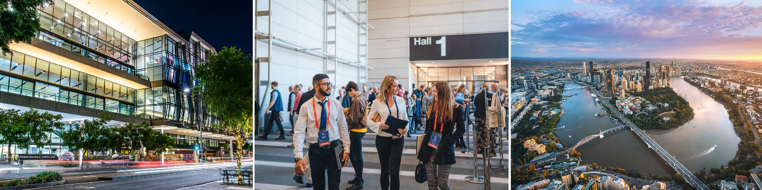

**Enquiries:** Gail Sawyer, Marketing and Communications Manager

**T**: +61 7 3308 3023 **M**: 0439 733 509 **E**: [gails@bcec.com.au](mailto:gails@bcec.com.au)

Date published: 15 December 2023

**ABOUT BCEC:**

Brisbane Convention & Exhibition Centre is owned by South Bank Corporation and proudly managed by leading international venue management specialists ASM Global.

**ABOUT ASM GLOBAL**

ASM Global is the world’s leading producer of entertainment experiences. It is the global leader in venue and event strategy and management - delivering locally tailored solutions and cutting-edge technologies to achieve maximum results for venue owners. The company’s elite venue network spans five continents, with a portfolio of more than 350 of the world’s most prestigious arenas, stadiums, convention, and exhibition centers, and performing arts venues.

Follow us on [Facebook](http://facebook.com/ASMGlobalLive), [Instagram](http://instagram.com/ASMGlobalLive), [LinkedIn](https://www.linkedin.com/company/asmgloballive/mycompany/) and [Twitter](http://twitter.com/ASMGlobalLive). [asmglobal.com](http://asmglobal.com/) 

**ASM GLOBAL (ASIA PACIFIC)**

From its Asia Pacific regional headquarters in Brisbane, Australia, ASM Global operates a network of venues that includes:

* Entertainment and Sports Arenas - Qudos Bank Arena, Sydney; RAC Arena, Perth; Brisbane Entertainment Centre; Newcastle Entertainment Centre; Aware Super Theatre at ICC Sydney; BCEC Great Hall, Brisbane; Cairns Arena: Bangkok Arena and EM Live Theatre, Bangkok (under development), Coca Cola Arena, Dubai; Kai Tak Sports Park Indoor Arena (under construction), Hong Kong; Axiata Arena, Kuala Lumpur; and Jeddah Arena, Saudi Arabia (under development),
* Live Performance Theatres - Brisbane, Cairns, Darwin, Sydney, Kuala Lumpur and Bahrain,
* Convention & Exhibition Centres - Brisbane, Cairns, Darwin, Newcastle, Sydney, Christchurch, Kuala Lumpur, Shenzhen, Bahrain (under construction), and Jeddah (under development), and;
* Stadiums - Suncorp Stadium in Brisbane, National Stadium Bukit Jalil in Kuala Lumpur, Kai Tak Sports Park Main Stadium, Hong Kong (under construction) and a significant ownership of VenuesLive, the operator of Accor Stadium, Sydney; CommBank Stadium, Parramatta; Optus Stadium, Perth and Central Coast Stadium, Gosford.

For more information, visit <http://www.asmglobal.com>